**Joint meeting (hybrid)**

**Thursday 20 February at 19:15**

***F2F Meeting:*** *City College Oceansgate, Units 6-12 Discovery Court,*

*Vivid Approach, Plymouth PL1 4RW*

***Zoom Link****:* [https://plymouth.zoom.us/j/3216324487?pwd=QTZxL1NRZzNpd2lkd2xRVkhnd2xVQT09](C:\\Users\\Owner\\Documents\\My text\\D&C\\Meetings\\MNWB\\MNWB flyer.docx)

 Smart Sound Connect Subsurface - a subsea testing environment in the heart of the South West

A presentation by Professor Alex Nimmo-Smith

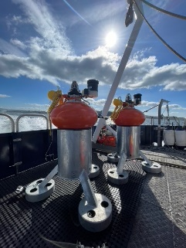**The talk.** The Smart Sound Connect Subsurface (SSCS) project, led by the University of Plymouth in collaboration with Plymouth Marine Laboratory and City College Plymouth, is enhancing subsea innovation in the South West. Funded by the Heart of the South West Local Enterprise Partnership, SSCS is extending Smart Sound Plymouth's infrastructure by installing an underwater acoustic communications and navigation array. This array enables real-time positioning and telemetry for testing advanced marine technologies. Instrumented seabed nodes provide real-time monitoring of oceanographic factors, creating a fully calibrated subsea testing environment.

Seabed communication and navigation nodes

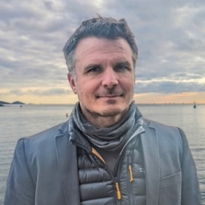**The speaker**. Prof Alex Nimmo-Smith is Professor of Marine Science & Technology at the University of Plymouth with over 20 years’ research experience in the observation of marine turbulence and suspended particles using various optical and acoustic techniques. He has developed novel imaging systems to visualise dynamic flows and the behaviour of microscopic particles and plankton within them, deploying these and other instrumentation on autonomous underwater vehicles (including Autosub 3, Autosub Long Range and Light AUVs). His submersible holographic microscope has been successfully commercialised under license by Sequoia Scientific, USA as the LISST-HOLO series of instruments – now used globally for diverse particle imaging applications. His research has encompassed a very diverse range of ocean environments, from the deep seamounts off the west coast of Scotland, to under sea-ice in the Arctic, to the tropical waters of the Indian Ocean. Most recently he has applied Particle Tracking and Image Velocimetry techniques to drone-acquired imagery to study the foraging behaviour of seabirds over turbulent wake features with application to assessing the impact of offshore renewable energy structures on the marine environment. He carries out teaching in underwater optics, physical oceanography, data analytics and autonomous marine systems. He is Principal Investigator for the Smart Sound Connect Subsurface project and a director of the National Centre for Coastal Autonomy.

**Contact:**  Branch Secretary Devon & Cornwall RINA/IMarEST or NI SW.