Joint meeting (hybrid)
Thursday 12 September at 19:15
F2F Meeting: City College Oceansgate, Units 6-12 Discovery Court,
Vivid Approach, Plymouth PL1 4RW
Zoom Link: https://plymouth.zoom.us/j/3216324487?pwd=QTZxL1NRZzNpd2lkd2xRVkhnd2xVQT09

‘An Entrepreneurial Journey Ashore’

A presentation by Paul Naranjo-Shepherd
Dragonfly Maritime

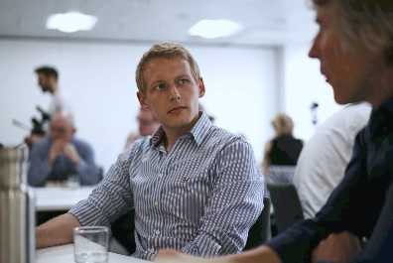

The talk centres on the ‘moving ashore’ experience and the challenges in running your own business.

The speaker. Paul has sailed cruise ships, tall ships, yachts, ferries and research vessels which have taken him all over the world. He founded Dragonfly Maritime and Whitehorse Maritime Academy. Whitehorse Maritime Academy is the UK's leading provider of on-demand MCA oral exam preparation, to both UK and international clients.

Car Parking: Free parking at front of building.
Further details if required: Branch Secretary NI SW or Devon & Cornwall RINA/IMarEST.

