**Joint meeting (hybrid)**

**Thursday 16 October at 19:15 (following Joint Branch AGM at 19:00)**

***F2F Meeting:*** *City College Oceansgate, Units 6-12 Discovery Court,*

*Vivid Approach, Plymouth PL1 4RW*

***Zoom Link****:* [https://plymouth.zoom.us/j/3216324487?pwd=QTZxL1NRZzNpd2lkd2xRVkhnd2xVQT09](C:\\Users\\Owner\\Documents\\My text\\D&C\\Meetings\\MNWB\\MNWB flyer.docx)

Project Moonshine

A presentation by Simon Mcloughlin

Managing Director, C-Fury Limited

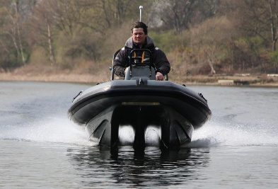**The talk.** C-Fury builds small craft for leisure and practical purposes. An overview will be given of its research into small craft performance technology with considerations of hull type, dynamics evolution and manufacturing. The 4m , 5 seat C-Fury Patrol has been used across multiple sectors, including leisure, yacht tender, commercial daughter craft, sonar survey and crew transfer.

Simon Mcloughlin on early production craft

**The speaker**. Simon Mcloughlin is a Co-Founder and Co-Developer of C-Fury Limited and has been Managing Director of the company for 20 years. He spent 10 years in Industrial Instrumentation and Process Control and holds a BSc in Combined Engineering.

~ ~ ~

**Joint Branch Annual General Meeting (Thursday 16 Oct, 19:00-19:15)**

Reports for 2024-2025 and Elections. Devon & Cornwall Joint RINA/IMarEST branch members, from Student to Fellow, are encouraged to stand for election to Committee to help guide its affairs of 2025-2028. Contact Geoff Davis, Hon Secretary.