**Joint meeting**

**Thursday 18 September at 19:15**

***F2F Meeting:*** *City College Oceansgate, Units 6-12 Discovery Court, Vivid Approach, Plymouth PL1 4RW*

***Zoom Link****:* <https://plymouth.zoom.us/j/3216324487?pwd=QTZxL1NRZzNpd2lkd2xRVkhnd2xVQT09>

Meeting ID: 321 632 4487 Passcode: 871608

‘The Salvage of HMNZS Manawanui’

A presentation by Dr CJ Manjarres-Wahlberg

**The talk –** CJ’s work has taken him all over the Southern hemisphere but one of his more recent challenges was working with the teams on the salvage of the vessel HMNZS Manawanui.

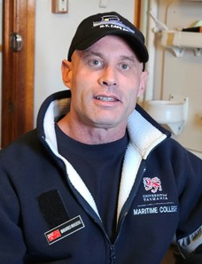**The speaker –** CJ is an Associate Fellow of the Royal Institute of Navigation, certified safety professional in Australia and New Zealand, Chartered Risk Manager and a Distinguished Fellow of the Chartered Institute of Management and Leadership. Beyond his professional endeavours, CJ is dedicated to charitable and educational initiatives. He is the Chairman of the Sea Heritage Foundation and the founder of the "Get into Maritime" training program, which provides Indigenous Australians with maritime training and employment pathways. CJ serves as an advisor on several industry and leadership panels and is an Ambassador for CHIRP. He currently serves as a First Officer and HSE Manager & Designated Person Ashore (Australia) for Heron Group New Zealand, a marine construction company headquartered in Auckland with operations in Australia under Heron Construction NZ.

**Contact:**  Gordon Foot - swengland.branch@nautinst.org

**Notice of Devon & Cornwall Joint RINA/IMarEST AGM – 16 October 2025**

Reports for 2024-2025 and Elections. Devon & Cornwall Joint RINA/IMarEST branch members, from Student to Fellow, are encouraged to stand for election to Committee to help guide its affairs of 2025-2028. Contact: secretary.dcjb@branches.imarest.org